[Title]

[authors]

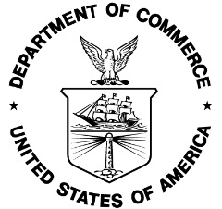

U.S. Department of Commerce
National Oceanic and Atmospheric Administration
National Marine Fisheries Service

NOAA Technical Memorandum NMFS-[F/SPO, OHC, OPR or OSF]-###
[Month] 2017

[Title]

[Authors]

NOAA Technical Memorandum NMFS-[F/SPO, OHC, OPR or OSF]-###
[month] [year]

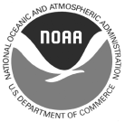

U.S. Department of Commerce
Wilbur L. Ross, Jr., Secretary

National Oceanic and Atmospheric Administration
RDML Tim Gallaudet, Ph.D., USN Ret., Acting NOAA Administrator

National Marine Fisheries Service
Chris Oliver, Assistant Administrator for Fisheries
Recommended citation:

[Authors]. [Year]. [Title] NOAA Tech. Memo. NMFS-[F/SPO, OHC, OPR or OSF]-###, ## p.

Copies of this report may be obtained from:

[office name]
National Oceanic and Atmospheric Administration
1315 East-West Highway [bldg./room]
Silver Spring, MD 20910
[or alternate address]

Or online at:
http://spo.nmfs.noaa.gov/tech-memos/
[or alternate URL for OHC, OSF or OPR pages]

ii

